Final Project Due Date
Student name: Student Number:
Project Title:
Select a project like

- Online Furniture Sale
- Online Car sale
- Online book store
- Online supermarket
- Online mobile store
- online pharmacy
- Online PC online sale
- Online wear
No Code out side the course slides are allowed in this final project
- Should use Bootstrap elements (nav, button, table, card, form) ____
- For all pages should use an appropriate colors, and clear texts , images, etc ____
- Login page (admin, customer): only admin can access admin home page and customer access customer home pages _____
- Master home page for customer and another admin home page for admin ____
    - In the master/customer page include the Menu _____
- Connection String : get all pages database connections from the Web.config _____

- For Customers Add following pages:

  - Items detail page that shows: item title, image, discount, price ____
  - Items Catalog page where Customer Get to see all items in a Repeater ____
    - ADD buy link to the Repeater where Customer can click to make the buy at the buy page _____
  - Create buy detail page
    - For buy use a function to calculate the price with the 10% discount if it is on a discount _____
    - for the buy it saves these details (customer name, item id , date of buy ) in the order table _____
  - Create a register page :A user can register himself as a customer as a customer from the customer registration page 1 _____
    - For the register page include proper validation ____
    - Use a class name Customer with register method to add a register user

For Admin Add following pages:
  - Send email page add a welcome email to a customer _____
  - Insert item page (use different type of controls: radio button, DropDownList, auto increment id) _____
  - In Insert item page include the div + table for proper style (aligned, background color,etc), Also Use command parameters for inserting name inputs ____
  - Use a c# code to check that all fields are entered (name, price, quantity ,etc)
  - Upload item image(according to its id) _____
  - Edit item page(according to its id) _____
  - Items List page within DataGrid order by category _____
  - Delete item page (according to its id) _____
  - If unauthorized access to insert, edit, delete pages then redirect user to the login page _____
  - Insert a new customer page. validate all inputs, ________
  - Customer Search page to search a customer based on letters within his name (like) and show his detail ___
  - Purchase report page that will show all customers total purchase amount of in a GridView, When click the view the customer order detail will be displayed at a order detail page _____
  - Also in that report page add a button that will show a detail of customer purchases in a GridView order by datedate _____

Project specification and GUI
- Create 3 tables
- myusers (name varchar, password varchar, role varchar, RegistDate date) --> use getdate() for the RegistDate as default
- itemsall (id auto increment int , name varchar, desc varchar, price int, quantity int, discountYes bit , discountNo bit ,category varchar, imagefilename varchar)
- orders (itemid, username, Buydate) --> use getdate() for the Buydate as default
- at Web.config file under <configuration> add

<add name="mynewdbString" connectionString="Data Source=.\sqlexpress;Initial Catalog= mynewdb; Integrated Security=True;Pooling=False" providerName="System.Data.SqlClient" />
</connectionStrings>

At All pages use this code for Database connections

var conString = System.Configuration.ConfigurationManager.ConnectionStrings["mynewdbString"];
conn = new SqlConnection(conString.ConnectionString);

- Create 2 master pages ( adminMaster page, customerMaster page)
- Use horizontal Menus inside the master pages
  - For the adminMaster page menu (home, Add item, Upload item image, Edit item, List Items, Delete item, Send email, Customer Search, Report Page )
  - For the customerMaster page menu (home, Catalog)

- adminHome page (logo, menu, welcome: name )

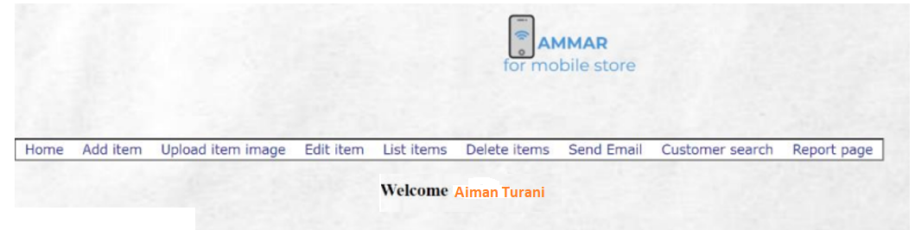

- customerHome page ( welcome: customer name + description , Discounted Items , Footer: contact detail: email,, Tel ,etc)

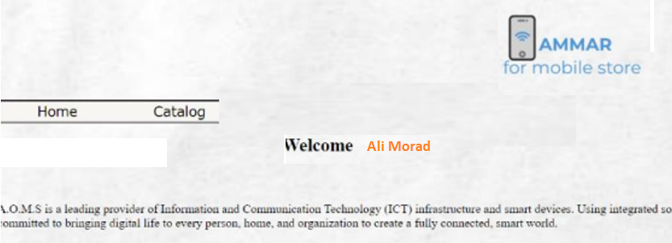
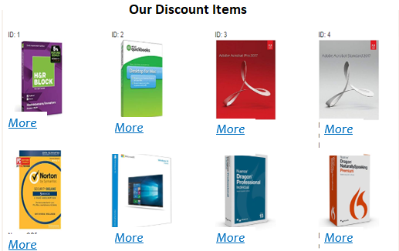

When the customer click the more it shows the item info at the
Product Detail page

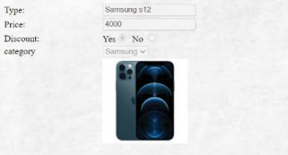

Login page (which will redirect users to maserHome page or customerHome Page)
( Enable Auto Login checkbox)
(Use div, table, and background color, image for proper design as shown)
th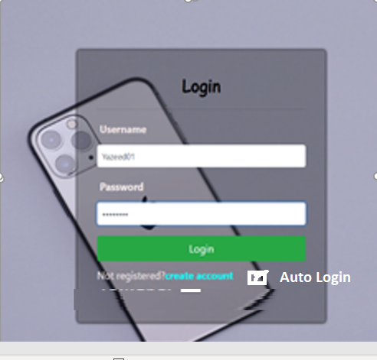
- register page for Customer (use required field and compare password validation)

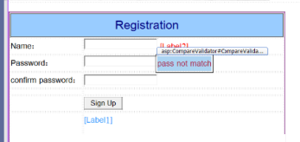

- Use a class name Customer with register() method to add a register user to the database
- If sign up correctly then direct to customer home page and save customer name, Id, Role at sessions
- For admin implement these pages (check for correct role session variable in the load page event to redirect unauthorized users to login page)

- AddItem page (make sure that all fields are not empty and correct type )
(Use command parameters for the item name, description )
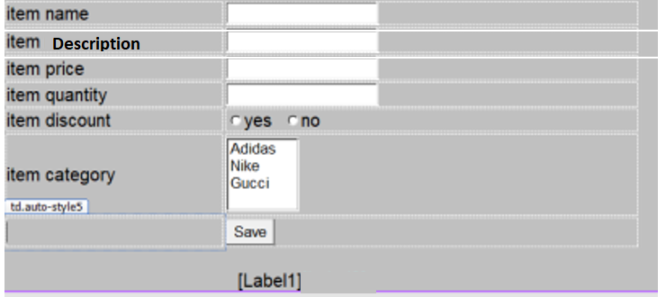
Show a successful message at label 1 when saved

- Item picture upload page
(note that you need to create an image folder )
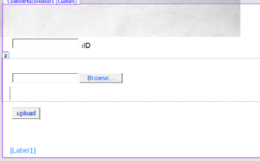

- DeleteItem page
(if wrong id print an error message in the label2 otherwise a successful at label1 )
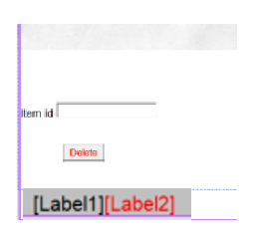

- List items page: Gridview ordered by Category

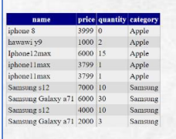

- EditItem page (based on id) when you fill the ID , all item data will be automatically fill all field – use text changed event )
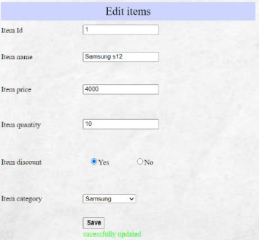

- email page

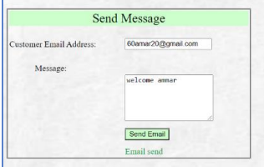

- customer search page to search a customer based on his name and show his detail

Customer search Name TextBox
Customers ListDown (to show all customers with similar letters typed in the TextBox

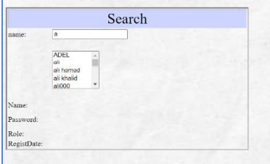

when selecting the customer name from the DropDown list the all customers info will be shown in Labels
Label1 customer name label2 customer id , etc......

- report page: that will show all customers total purchase amount of in a GridView

“Select user…, sum (price) from order,items where order.itemid = items.Id group by username”
Also in that report page add a search button that and a text box to input the customer name will show his buys orders in a GridView order by date

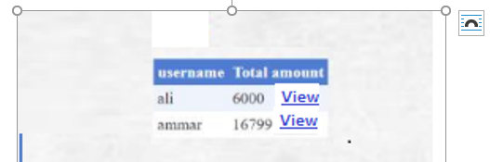

When click at View that customer orders detail will be shown at customer order detail page

“Select name, price, buydate from order,items where order.itemid = items.Id and customername = .. Session[“username”]…. Order by buydate “

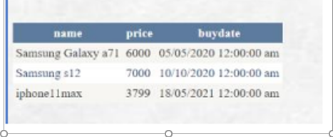

- For customer a create the following page

- Item Catalog page (all items into a Repeater searched by category)

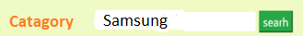
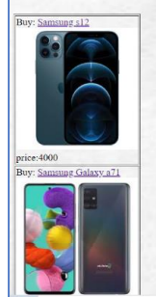

- When customer click on the item name it will redirect to the buyItem page
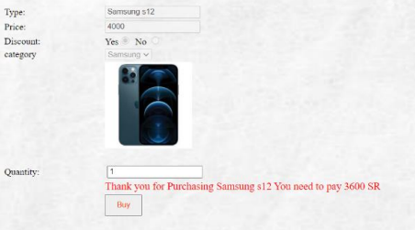

  - the quantity – TextBox1.Text
  - and a message on the label show how much you need to pay – if the item has a discount then subtract 10% from the price (use a function to do that)
………
boolean disc = (boolean) reader [“discountYes”]
{ if (disc == yes …………
Call discount function

  - the buy record should be inserted in the order table

